Dependent Variable: Y1
Method: Least Squares
Date: 03/18/06 Time: 16:07
Sample: 1 101
Included observations: 101
Y1=C(1)+C(2)*X+C(3)*X^2+C(4)*X^3
 | Coefficient | Std. Error | t-Statistic | Prob.
C(1) | 117.6130 | 13.73384 | 8.563739 | 0.0000
C(2) | 35.32189 | 7.853167 | 4.497790 | 0.0000
C(3) | -41.74237 | 1.204384 | -34.65867 | 0.0000
C(4) | -0.492458 | 0.470520 | -1.046625 | 0.2979
R-squared | 0.929589 | Mean dependent var |  | -237.1971
Adjusted R-squared | 0.927411 | S.D. dependent var |  | 341.5009
S.E. of regression | 92.00806 | Akaike info criterion |  | 11.92043
Sum squared resid | 821151.8 | Schwarz criterion |  | 12.02400
Log likelihood | -597.9816 | F-statistic |  | 426.8760
Durbin-Watson stat | 1.974198 | Prob(F-statistic) |  | 0.000000

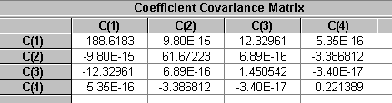

Dependent Variable: Y2
Method: Least Squares
Date: 03/18/06 Time: 16:07
Sample: 1 101
Included observations: 101
Y2=C(1)+C(2)*X+C(3)*X^2+C(4)*X^3
 | Coefficient | Std. Error | t-Statistic | Prob.
C(1) | 138.5760 | 14.70540 | 9.423482 | 0.0000
C(2) | 18.29509 | 8.408715 | 2.175730 | 0.0320
C(3) | -45.60891 | 1.289585 | -35.36712 | 0.0000
C(4) | 0.399369 | 0.503806 | 0.792705 | 0.4299
R-squared | 0.930771 | Mean dependent var |  | -249.0997
Adjusted R-squared | 0.928630 | S.D. dependent var |  | 368.7670
S.E. of regression | 98.51689 | Akaike info criterion |  | 12.05713
Sum squared resid | 941441.1 | Schwarz criterion |  | 12.16070
Log likelihood | -604.8851 | F-statistic |  | 434.7146
Durbin-Watson stat | 2.099633 | Prob(F-statistic) |  | 0.000000

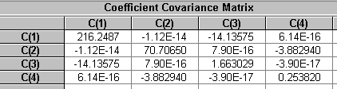

Dependent Variable: Y3
Method: Least Squares
Date: 03/18/06 Time: 16:07
Sample: 1 101
Included observations: 101
Y3=C(1)+C(2)*X+C(3)*X^2+C(4)*X^3
 | Coefficient | Std. Error | t-Statistic | Prob.
C(1) | 126.6411 | 15.96081 | 7.934503 | 0.0000
C(2) | 35.98105 | 9.126573 | 3.942450 | 0.0002
C(3) | -42.90352 | 1.399678 | -30.65243 | 0.0000
C(4) | -0.529872 | 0.546816 | -0.969013 | 0.3349
R-squared | 0.911485 | Mean dependent var |  | -238.0389
Adjusted R-squared | 0.908747 | S.D. dependent var |  | 353.9690
S.E. of regression | 106.9273 | Akaike info criterion |  | 12.22097
Sum squared resid | 1109045. | Schwarz criterion |  | 12.32454
Log likelihood | -613.1592 | F-statistic |  | 332.9514
Durbin-Watson stat | 1.795076 | Prob(F-statistic) |  | 0.000000

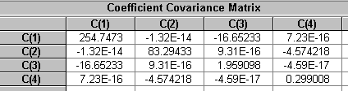

Dependent Variable: Y4
Method: Least Squares
Date: 03/18/06 Time: 16:07
Sample: 1 101
Included observations: 101
Y4=C(1)+C(2)*X+C(3)*X^2+C(4)*X^3
 | Coefficient | Std. Error | t-Statistic | Prob.
C(1) | 164.8786 | 13.90346 | 11.85882 | 0.0000
C(2) | 24.76212 | 7.950157 | 3.114670 | 0.0024
C(3) | -45.91646 | 1.219259 | -37.65931 | 0.0000
C(4) | 0.207733 | 0.476331 | 0.436110 | 0.6637
R-squared | 0.939096 | Mean dependent var |  | -225.4113
Adjusted R-squared | 0.937212 | S.D. dependent var |  | 371.7221
S.E. of regression | 93.14440 | Akaike info criterion |  | 11.94498
Sum squared resid | 841560.4 | Schwarz criterion |  | 12.04855
Log likelihood | -599.2214 | F-statistic |  | 498.5534
Durbin-Watson stat | 1.940828 | Prob(F-statistic) |  | 0.000000

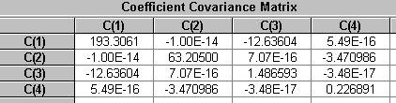

Dependent Variable: Y5
Method: Least Squares
Date: 03/18/06 Time: 16:07
Sample: 1 101
Included observations: 101
Y5=C(1)+C(2)*X+C(3)*X^2+C(4)*X^3
 | Coefficient | Std. Error | t-Statistic | Prob.
C(1) | 145.5758 | 16.71413 | 8.709748 | 0.0000
C(2) | 33.62347 | 9.557329 | 3.518082 | 0.0007
C(3) | -43.15470 | 1.465740 | -29.44227 | 0.0000
C(4) | -0.179107 | 0.572624 | -0.312782 | 0.7551
R-squared | 0.905757 | Mean dependent var |  | -221.2391
Adjusted R-squared | 0.902842 | S.D. dependent var |  | 359.2348
S.E. of regression | 111.9741 | Akaike info criterion |  | 12.31321
Sum squared resid | 1216205. | Schwarz criterion |  | 12.41678
Log likelihood | -617.8171 | F-statistic |  | 310.7506
Durbin-Watson stat | 2.074113 | Prob(F-statistic) |  | 0.000000

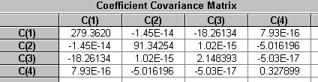

Dependent Variable: Y6
Method: Least Squares
Date: 03/18/06 Time: 16:07
Sample: 1 101
Included observations: 101
Y6=C(1)+C(2)*X+C(3)*X^2+C(4)*X^3
 | Coefficient | Std. Error | t-Statistic | Prob.
C(1) | 136.4421 | 16.56220 | 8.238164 | 0.0000
C(2) | 28.84850 | 9.470455 | 3.046158 | 0.0030
C(3) | -43.42222 | 1.452417 | -29.89653 | 0.0000
C(4) | -0.104504 | 0.567419 | -0.184175 | 0.8543
R-squared | 0.906965 | Mean dependent var |  | -232.6468
Adjusted R-squared | 0.904087 | S.D. dependent var |  | 358.2731
S.E. of regression | 110.9563 | Akaike info criterion |  | 12.29495
Sum squared resid | 1194196. | Schwarz criterion |  | 12.39852
Log likelihood | -616.8949 | F-statistic |  | 315.2055
Durbin-Watson stat | 2.247377 | Prob(F-statistic) |  | 0.000000

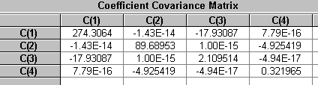

Dependent Variable: Y7
Method: Least Squares
Date: 03/18/06 Time: 16:08
Sample: 1 101
Included observations: 101
Y7=C(1)+C(2)*X+C(3)*X^2+C(4)*X^3
 | Coefficient | Std. Error | t-Statistic | Prob.
C(1) | 153.7266 | 14.77474 | 10.40469 | 0.0000
C(2) | 18.60111 | 8.448368 | 2.201740 | 0.0301
C(3) | -44.31237 | 1.295666 | -34.20045 | 0.0000
C(4) | 0.348398 | 0.506181 | 0.688288 | 0.4929
R-squared | 0.926366 | Mean dependent var |  | -222.9285
Adjusted R-squared | 0.924089 | S.D. dependent var |  | 359.2532
S.E. of regression | 98.98146 | Akaike info criterion |  | 12.06654
Sum squared resid | 950341.0 | Schwarz criterion |  | 12.17011
Log likelihood | -605.3603 | F-statistic |  | 406.7756
Durbin-Watson stat | 2.087736 | Prob(F-statistic) |  | 0.000000

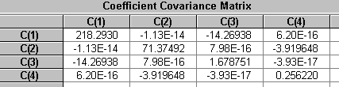

Dependent Variable: Y8
Method: Least Squares
Date: 03/18/06 Time: 16:08
Sample: 1 101
Included observations: 101
Y8=C(1)+C(2)*X+C(3)*X^2+C(4)*X^3
 | Coefficient | Std. Error | t-Statistic | Prob.
C(1) | 168.1556 | 14.37743 | 11.69580 | 0.0000
C(2) | 23.21476 | 8.221177 | 2.823776 | 0.0058
C(3) | -45.63409 | 1.260824 | -36.19387 | 0.0000
C(4) | 0.733237 | 0.492569 | 1.488596 | 0.1398
R-squared | 0.936139 | Mean dependent var |  | -219.7342
Adjusted R-squared | 0.934164 | S.D. dependent var |  | 375.3896
S.E. of regression | 96.31969 | Akaike info criterion |  | 12.01202
Sum squared resid | 899915.8 | Schwarz criterion |  | 12.11559
Log likelihood | -602.6071 | F-statistic |  | 473.9727
Durbin-Watson stat | 2.233075 | Prob(F-statistic) |  | 0.000000

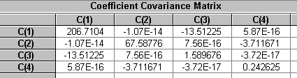

Dependent Variable: Y9
Method: Least Squares
Date: 03/18/06 Time: 16:08
Sample: 1 101
Included observations: 101
Y9=C(1)+C(2)*X+C(3)*X^2+C(4)*X^3
 | Coefficient | Std. Error | t-Statistic | Prob.
C(1) | 153.5068 | 15.30268 | 10.03137 | 0.0000
C(2) | 24.02018 | 8.750249 | 2.745085 | 0.0072
C(3) | -46.16700 | 1.341964 | -34.40257 | 0.0000
C(4) | 0.412531 | 0.524268 | 0.786869 | 0.4333
R-squared | 0.928482 | Mean dependent var |  | -238.9127
Adjusted R-squared | 0.926270 | S.D. dependent var |  | 377.5547
S.E. of regression | 102.5183 | Akaike info criterion |  | 12.13676
Sum squared resid | 1019470. | Schwarz criterion |  | 12.24033
Log likelihood | -608.9063 | F-statistic |  | 419.7678
Durbin-Watson stat | 1.814182 | Prob(F-statistic) |  | 0.000000

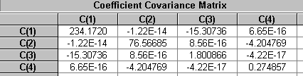

Dependent Variable: Y10
Method: Least Squares
Date: 03/18/06 Time: 16:08
Sample: 1 101
Included observations: 101
Y10=C(1)+C(2)*X+C(3)*X^2+C(4)*X^3
 | Coefficient | Std. Error | t-Statistic | Prob.
C(1) | 144.8358 | 15.22934 | 9.510310 | 0.0000
C(2) | 28.00946 | 8.708314 | 3.216405 | 0.0018
C(3) | -44.53205 | 1.335532 | -33.34405 | 0.0000
C(4) | 0.102766 | 0.521756 | 0.196961 | 0.8443
R-squared | 0.924280 | Mean dependent var |  | -233.6867
Adjusted R-squared | 0.921938 | S.D. dependent var |  | 365.1702
S.E. of regression | 102.0270 | Akaike info criterion |  | 12.12715
Sum squared resid | 1009722. | Schwarz criterion |  | 12.23072
Log likelihood | -608.4211 | F-statistic |  | 394.6779
Durbin-Watson stat | 2.152210 | Prob(F-statistic) |  | 0.000000

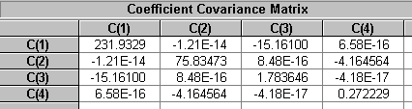

Dependent Variable: Y11
Method: Least Squares
Date: 03/18/06 Time: 16:08
Sample: 1 101
Included observations: 101
Y11=C(1)+C(2)*X+C(3)*X^2+C(4)*X^3
 | Coefficient | Std. Error | t-Statistic | Prob.
C(1) | 139.2474 | 15.82785 | 8.797616 | 0.0000
C(2) | 22.93315 | 9.050549 | 2.533897 | 0.0129
C(3) | -42.97876 | 1.388018 | -30.96411 | 0.0000
C(4) | 0.353191 | 0.542261 | 0.651331 | 0.5164
R-squared | 0.913200 | Mean dependent var |  | -226.0720
Adjusted R-squared | 0.910515 | S.D. dependent var |  | 354.4714
S.E. of regression | 106.0366 | Akaike info criterion |  | 12.20424
Sum squared resid | 1090646. | Schwarz criterion |  | 12.30781
Log likelihood | -612.3144 | F-statistic |  | 340.1693
Durbin-Watson stat | 2.149719 | Prob(F-statistic) |  | 0.000000

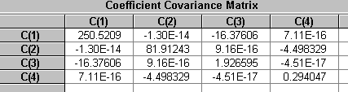

Dependent Variable: Y12
Method: Least Squares
Date: 03/18/06 Time: 16:08
Sample: 1 101
Included observations: 101
Y12=C(1)+C(2)*X+C(3)*X^2+C(4)*X^3
 | Coefficient | Std. Error | t-Statistic | Prob.
C(1) | 140.4769 | 14.89200 | 9.433049 | 0.0000
C(2) | 29.95405 | 8.515414 | 3.517627 | 0.0007
C(3) | -44.22254 | 1.305949 | -33.86239 | 0.0000
C(4) | 0.415025 | 0.510198 | 0.813458 | 0.4179
R-squared | 0.928571 | Mean dependent var |  | -235.4147
Adjusted R-squared | 0.926362 | S.D. dependent var |  | 367.6512
S.E. of regression | 99.76698 | Akaike info criterion |  | 12.08235
Sum squared resid | 965484.7 | Schwarz criterion |  | 12.18592
Log likelihood | -606.1587 | F-statistic |  | 420.3317
Durbin-Watson stat | 2.146696 | Prob(F-statistic) |  | 0.000000

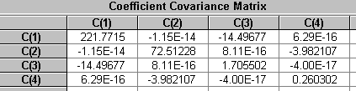

Dependent Variable: Y13
Method: Least Squares
Date: 03/18/06 Time: 16:08
Sample: 1 101
Included observations: 101
Y13=C(1)+C(2)*X+C(3)*X^2+C(4)*X^3
 | Coefficient | Std. Error | t-Statistic | Prob.
C(1) | 142.8533 | 15.39562 | 9.278828 | 0.0000
C(2) | 36.02054 | 8.803391 | 4.091666 | 0.0001
C(3) | -44.82711 | 1.350114 | -33.20247 | 0.0000
C(4) | -0.382331 | 0.527453 | -0.724863 | 0.4703
R-squared | 0.923826 | Mean dependent var |  | -238.1771
Adjusted R-squared | 0.921470 | S.D. dependent var |  | 368.0547
S.E. of regression | 103.1409 | Akaike info criterion |  | 12.14887
Sum squared resid | 1031891. | Schwarz criterion |  | 12.25244
Log likelihood | -609.5178 | F-statistic |  | 392.1312
Durbin-Watson stat | 2.186769 | Prob(F-statistic) |  | 0.000000

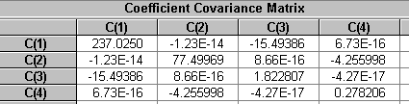

Dependent Variable: Y14
Method: Least Squares
Date: 03/18/06 Time: 16:08
Sample: 1 101
Included observations: 101
Y14=C(1)+C(2)*X+C(3)*X^2+C(4)*X^3
 | Coefficient | Std. Error | t-Statistic | Prob.
C(1) | 128.2076 | 13.62285 | 9.411218 | 0.0000
C(2) | 46.98090 | 7.789702 | 6.031155 | 0.0000
C(3) | -43.77676 | 1.194651 | -36.64396 | 0.0000
C(4) | -1.254776 | 0.466718 | -2.688511 | 0.0084
R-squared | 0.936459 | Mean dependent var |  | -243.8949
Adjusted R-squared | 0.934494 | S.D. dependent var |  | 356.5841
S.E. of regression | 91.26451 | Akaike info criterion |  | 11.90420
Sum squared resid | 807933.4 | Schwarz criterion |  | 12.00777
Log likelihood | -597.1621 | F-statistic |  | 476.5272
Durbin-Watson stat | 2.194306 | Prob(F-statistic) |  | 0.000000

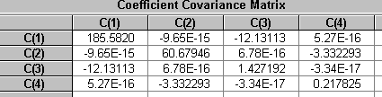

Dependent Variable: Y15
Method: Least Squares
Date: 03/18/06 Time: 16:08
Sample: 1 101
Included observations: 101
Y15=C(1)+C(2)*X+C(3)*X^2+C(4)*X^3
 | Coefficient | Std. Error | t-Statistic | Prob.
C(1) | 124.4674 | 13.94570 | 8.925145 | 0.0000
C(2) | 21.21527 | 7.974313 | 2.660451 | 0.0091
C(3) | -43.83266 | 1.222964 | -35.84133 | 0.0000
C(4) | 0.309222 | 0.477779 | 0.647207 | 0.5190
R-squared | 0.933022 | Mean dependent var |  | -248.1102
Adjusted R-squared | 0.930950 | S.D. dependent var |  | 355.5438
S.E. of regression | 93.42742 | Akaike info criterion |  | 11.95105
Sum squared resid | 846682.2 | Schwarz criterion |  | 12.05461
Log likelihood | -599.5278 | F-statistic |  | 450.4100
Durbin-Watson stat | 2.298602 | Prob(F-statistic) |  | 0.000000

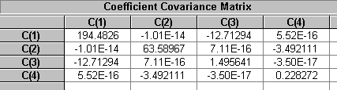

Dependent Variable: Y16
Method: Least Squares
Date: 03/18/06 Time: 16:09
Sample: 1 101
Included observations: 101
Y16=C(1)+C(2)*X+C(3)*X^2+C(4)*X^3
 | Coefficient | Std. Error | t-Statistic | Prob.
C(1) | 146.9292 | 14.13132 | 10.39741 | 0.0000
C(2) | 33.42806 | 8.080452 | 4.136905 | 0.0001
C(3) | -43.06078 | 1.239242 | -34.74769 | 0.0000
C(4) | -0.333449 | 0.484138 | -0.688748 | 0.4926
R-squared | 0.929799 | Mean dependent var |  | -219.0875
Adjusted R-squared | 0.927627 | S.D. dependent var |  | 351.9083
S.E. of regression | 94.67095 | Akaike info criterion |  | 11.97749
Sum squared resid | 869371.1 | Schwarz criterion |  | 12.08106
Log likelihood | -600.8632 | F-statistic |  | 428.2457
Durbin-Watson stat | 2.314550 | Prob(F-statistic) |  | 0.000000

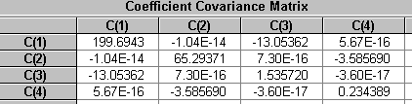

Dependent Variable: Y17
Method: Least Squares
Date: 03/18/06 Time: 16:09
Sample: 1 101
Included observations: 101
Y17=C(1)+C(2)*X+C(3)*X^2+C(4)*X^3
 | Coefficient | Std. Error | t-Statistic | Prob.
C(1) | 153.9171 | 13.94463 | 11.03773 | 0.0000
C(2) | 28.14378 | 7.973700 | 3.529576 | 0.0006
C(3) | -44.54460 | 1.222870 | -36.42628 | 0.0000
C(4) | 0.175567 | 0.477742 | 0.367493 | 0.7141
R-squared | 0.936079 | Mean dependent var |  | -224.7120
Adjusted R-squared | 0.934102 | S.D. dependent var |  | 363.9201
S.E. of regression | 93.42023 | Akaike info criterion |  | 11.95089
Sum squared resid | 846551.9 | Schwarz criterion |  | 12.05446
Log likelihood | -599.5200 | F-statistic |  | 473.5018
Durbin-Watson stat | 1.896989 | Prob(F-statistic) |  | 0.000000

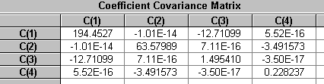

Dependent Variable: Y18
Method: Least Squares
Date: 03/18/06 Time: 16:09
Sample: 1 101
Included observations: 101
Y18=C(1)+C(2)*X+C(3)*X^2+C(4)*X^3
 | Coefficient | Std. Error | t-Statistic | Prob.
C(1) | 184.0105 | 13.79466 | 13.33926 | 0.0000
C(2) | 30.08863 | 7.887946 | 3.814508 | 0.0002
C(3) | -47.19494 | 1.209718 | -39.01317 | 0.0000
C(4) | -0.036208 | 0.472604 | -0.076614 | 0.9391
R-squared | 0.943166 | Mean dependent var |  | -217.1465
Adjusted R-squared | 0.941408 | S.D. dependent var |  | 381.7909
S.E. of regression | 92.41554 | Akaike info criterion |  | 11.92927
Sum squared resid | 828441.2 | Schwarz criterion |  | 12.03283
Log likelihood | -598.4279 | F-statistic |  | 536.5720
Durbin-Watson stat | 2.187243 | Prob(F-statistic) |  | 0.000000

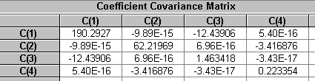

Dependent Variable: Y19
Method: Least Squares
Date: 03/18/06 Time: 16:09
Sample: 1 101
Included observations: 101
Y19=C(1)+C(2)*X+C(3)*X^2+C(4)*X^3
 | Coefficient | Std. Error | t-Statistic | Prob.
C(1) | 151.7048 | 14.61900 | 10.37723 | 0.0000
C(2) | 32.61332 | 8.359313 | 3.901435 | 0.0002
C(3) | -45.65486 | 1.282008 | -35.61198 | 0.0000
C(4) | -0.169216 | 0.500846 | -0.337860 | 0.7362
R-squared | 0.932919 | Mean dependent var |  | -236.3615
Adjusted R-squared | 0.930844 | S.D. dependent var |  | 372.4239
S.E. of regression | 97.93809 | Akaike info criterion |  | 12.04535
Sum squared resid | 930411.3 | Schwarz criterion |  | 12.14892
Log likelihood | -604.2900 | F-statistic |  | 449.6707
Durbin-Watson stat | 2.061512 | Prob(F-statistic) |  | 0.000000

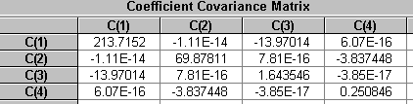

Dependent Variable: Y20
Method: Least Squares
Date: 03/18/06 Time: 16:09
Sample: 1 101
Included observations: 101
Y20=C(1)+C(2)*X+C(3)*X^2+C(4)*X^3
 | Coefficient | Std. Error | t-Statistic | Prob.
C(1) | 181.4892 | 15.48451 | 11.72069 | 0.0000
C(2) | 35.62333 | 8.854223 | 4.023315 | 0.0001
C(3) | -48.13889 | 1.357909 | -35.45074 | 0.0000
C(4) | -0.397231 | 0.530498 | -0.748788 | 0.4558
R-squared | 0.931880 | Mean dependent var |  | -227.6914
Adjusted R-squared | 0.929773 | S.D. dependent var |  | 391.4538
S.E. of regression | 103.7365 | Akaike info criterion |  | 12.16038
Sum squared resid | 1043842. | Schwarz criterion |  | 12.26395
Log likelihood | -610.0993 | F-statistic |  | 442.3202
Durbin-Watson stat | 2.164159 | Prob(F-statistic) |  | 0.000000

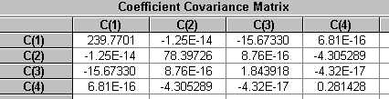

Dependent Variable: Y21
Method: Least Squares
Date: 03/18/06 Time: 16:09
Sample: 1 101
Included observations: 101
Y21=C(1)+C(2)*X+C(3)*X^2+C(4)*X^3
 | Coefficient | Std. Error | t-Statistic | Prob.
C(1) | 144.1649 | 16.21382 | 8.891486 | 0.0000
C(2) | 40.34342 | 9.271248 | 4.351455 | 0.0000
C(3) | -44.13210 | 1.421866 | -31.03817 | 0.0000
C(4) | -0.567790 | 0.555484 | -1.022154 | 0.3093
R-squared | 0.914487 | Mean dependent var |  | -230.9579
Adjusted R-squared | 0.911843 | S.D. dependent var |  | 365.8387
S.E. of regression | 108.6224 | Akaike info criterion |  | 12.25243
Sum squared resid | 1144485. | Schwarz criterion |  | 12.35600
Log likelihood | -614.7477 | F-statistic |  | 345.7778
Durbin-Watson stat | 2.048711 | Prob(F-statistic) |  | 0.000000

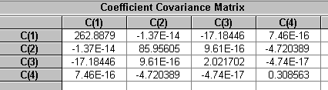

Dependent Variable: Y22
Method: Least Squares
Date: 03/18/06 Time: 16:09
Sample: 1 101
Included observations: 101
Y22=C(1)+C(2)*X+C(3)*X^2+C(4)*X^3
 | Coefficient | Std. Error | t-Statistic | Prob.
C(1) | 151.6490 | 13.70743 | 11.06327 | 0.0000
C(2) | 29.94048 | 7.838069 | 3.819880 | 0.0002
C(3) | -44.39983 | 1.202069 | -36.93618 | 0.0000
C(4) | 0.038521 | 0.469616 | 0.082026 | 0.9348
R-squared | 0.937668 | Mean dependent var |  | -225.7496
Adjusted R-squared | 0.935740 | S.D. dependent var |  | 362.2591
S.E. of regression | 91.83117 | Akaike info criterion |  | 11.91658
Sum squared resid | 817997.5 | Schwarz criterion |  | 12.02015
Log likelihood | -597.7872 | F-statistic |  | 486.3916
Durbin-Watson stat | 2.071935 | Prob(F-statistic) |  | 0.000000

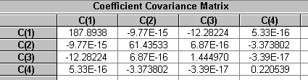

Dependent Variable: Y23
Method: Least Squares
Date: 03/18/06 Time: 16:09
Sample: 1 101
Included observations: 101
Y23=C(1)+C(2)*X+C(3)*X^2+C(4)*X^3
 | Coefficient | Std. Error | t-Statistic | Prob.
C(1) | 167.4617 | 15.49027 | 10.81077 | 0.0000
C(2) | 32.86626 | 8.857516 | 3.710550 | 0.0003
C(3) | -45.45817 | 1.358414 | -33.46414 | 0.0000
C(4) | -0.269630 | 0.530695 | -0.508070 | 0.6126
R-squared | 0.924394 | Mean dependent var |  | -218.9327
Adjusted R-squared | 0.922055 | S.D. dependent var |  | 371.7059
S.E. of regression | 103.7751 | Akaike info criterion |  | 12.16113
Sum squared resid | 1044619. | Schwarz criterion |  | 12.26470
Log likelihood | -610.1369 | F-statistic |  | 395.3198
Durbin-Watson stat | 2.037403 | Prob(F-statistic) |  | 0.000000

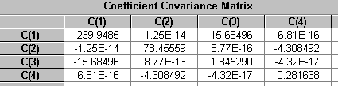

Dependent Variable: Y24
Method: Least Squares
Date: 03/18/06 Time: 16:09
Sample: 1 101
Included observations: 101
Y24=C(1)+C(2)*X+C(3)*X^2+C(4)*X^3
 | Coefficient | Std. Error | t-Statistic | Prob.
C(1) | 140.5631 | 14.03454 | 10.01552 | 0.0000
C(2) | 37.63078 | 8.025110 | 4.689130 | 0.0000
C(3) | -42.64486 | 1.230754 | -34.64937 | 0.0000
C(4) | -0.469666 | 0.480822 | -0.976798 | 0.3311
R-squared | 0.930143 | Mean dependent var |  | -221.9182
Adjusted R-squared | 0.927983 | S.D. dependent var |  | 350.3588
S.E. of regression | 94.02255 | Akaike info criterion |  | 11.96374
Sum squared resid | 857503.3 | Schwarz criterion |  | 12.06731
Log likelihood | -600.1691 | F-statistic |  | 430.5172
Durbin-Watson stat | 2.180258 | Prob(F-statistic) |  | 0.000000

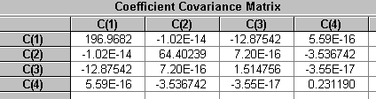

Dependent Variable: Y25
Method: Least Squares
Date: 03/18/06 Time: 16:10
Sample: 1 101
Included observations: 101
Y25=C(1)+C(2)*X+C(3)*X^2+C(4)*X^3
 | Coefficient | Std. Error | t-Statistic | Prob.
C(1) | 177.1963 | 13.60402 | 13.02529 | 0.0000
C(2) | 25.05296 | 7.778937 | 3.220615 | 0.0017
C(3) | -46.50823 | 1.193000 | -38.98426 | 0.0000
C(4) | 0.562497 | 0.466073 | 1.206887 | 0.2304
R-squared | 0.944102 | Mean dependent var |  | -218.1236
Adjusted R-squared | 0.942374 | S.D. dependent var |  | 379.6565
S.E. of regression | 91.13838 | Akaike info criterion |  | 11.90143
Sum squared resid | 805701.9 | Schwarz criterion |  | 12.00500
Log likelihood | -597.0224 | F-statistic |  | 546.1059
Durbin-Watson stat | 1.722516 | Prob(F-statistic) |  | 0.000000

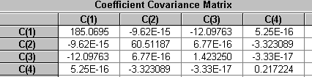

Dependent Variable: Y26
Method: Least Squares
Date: 03/18/06 Time: 16:10
Sample: 1 101
Included observations: 101
Y26=C(1)+C(2)*X+C(3)*X^2+C(4)*X^3
 | Coefficient | Std. Error | t-Statistic | Prob.
C(1) | 146.6865 | 14.99375 | 9.783175 | 0.0000
C(2) | 37.37828 | 8.573601 | 4.359694 | 0.0000
C(3) | -44.62966 | 1.314872 | -33.94220 | 0.0000
C(4) | -0.373554 | 0.513685 | -0.727204 | 0.4689
R-squared | 0.927336 | Mean dependent var |  | -232.6656
Adjusted R-squared | 0.925088 | S.D. dependent var |  | 367.0032
S.E. of regression | 100.4487 | Akaike info criterion |  | 12.09597
Sum squared resid | 978724.4 | Schwarz criterion |  | 12.19954
Log likelihood | -606.8465 | F-statistic |  | 412.6356
Durbin-Watson stat | 1.956914 | Prob(F-statistic) |  | 0.000000

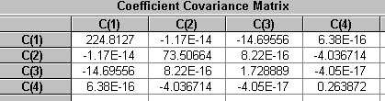

Dependent Variable: Y27
Method: Least Squares
Date: 03/18/06 Time: 16:10
Sample: 1 101
Included observations: 101
Y27=C(1)+C(2)*X+C(3)*X^2+C(4)*X^3
 | Coefficient | Std. Error | t-Statistic | Prob.
C(1) | 137.6855 | 15.28238 | 9.009427 | 0.0000
C(2) | 27.58109 | 8.738640 | 3.156222 | 0.0021
C(3) | -44.58607 | 1.340183 | -33.26864 | 0.0000
C(4) | 0.247722 | 0.523573 | 0.473138 | 0.6372
R-squared | 0.924492 | Mean dependent var |  | -241.2962
Adjusted R-squared | 0.922156 | S.D. dependent var |  | 366.9556
S.E. of regression | 102.3823 | Akaike info criterion |  | 12.13410
Sum squared resid | 1016767. | Schwarz criterion |  | 12.23767
Log likelihood | -608.7722 | F-statistic |  | 395.8758
Durbin-Watson stat | 2.050747 | Prob(F-statistic) |  | 0.000000

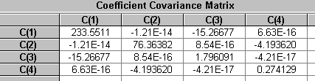

Dependent Variable: Y28
Method: Least Squares
Date: 03/18/06 Time: 16:10
Sample: 1 101
Included observations: 101
Y28=C(1)+C(2)*X+C(3)*X^2+C(4)*X^3
 | Coefficient | Std. Error | t-Statistic | Prob.
C(1) | 150.1671 | 14.48161 | 10.36950 | 0.0000
C(2) | 30.14964 | 8.280752 | 3.640930 | 0.0004
C(3) | -45.22742 | 1.269960 | -35.61326 | 0.0000
C(4) | -0.161778 | 0.496139 | -0.326073 | 0.7451
R-squared | 0.932417 | Mean dependent var |  | -234.2659
Adjusted R-squared | 0.930327 | S.D. dependent var |  | 367.5506
S.E. of regression | 97.01766 | Akaike info criterion |  | 12.02646
Sum squared resid | 913005.4 | Schwarz criterion |  | 12.13003
Log likelihood | -603.3363 | F-statistic |  | 446.0890
Durbin-Watson stat | 2.480299 | Prob(F-statistic) |  | 0.000000

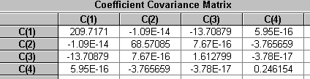

Dependent Variable: Y29
Method: Least Squares
Date: 03/18/06 Time: 16:10
Sample: 1 101
Included observations: 101
Y29=C(1)+C(2)*X+C(3)*X^2+C(4)*X^3
 | Coefficient | Std. Error | t-Statistic | Prob.
C(1) | 169.7510 | 14.80466 | 11.46605 | 0.0000
C(2) | 21.16298 | 8.465478 | 2.499916 | 0.0141
C(3) | -45.63756 | 1.298290 | -35.15205 | 0.0000
C(4) | 0.611231 | 0.507207 | 1.205094 | 0.2311
R-squared | 0.931467 | Mean dependent var |  | -218.1683
Adjusted R-squared | 0.929347 | S.D. dependent var |  | 373.1371
S.E. of regression | 99.18192 | Akaike info criterion |  | 12.07059
Sum squared resid | 954194.2 | Schwarz criterion |  | 12.17416
Log likelihood | -605.5646 | F-statistic |  | 439.4587
Durbin-Watson stat | 2.245069 | Prob(F-statistic) |  | 0.000000

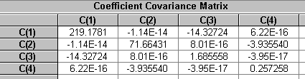

Dependent Variable: Y30
Method: Least Squares
Date: 03/18/06 Time: 16:10
Sample: 1 101
Included observations: 101
Y30=C(1)+C(2)*X+C(3)*X^2+C(4)*X^3
 | Coefficient | Std. Error | t-Statistic | Prob.
C(1) | 148.2442 | 14.15123 | 10.47571 | 0.0000
C(2) | 29.53734 | 8.091837 | 3.650264 | 0.0004
C(3) | -45.97916 | 1.240988 | -37.05046 | 0.0000
C(4) | 0.184348 | 0.484820 | 0.380240 | 0.7046
R-squared | 0.938212 | Mean dependent var |  | -242.5787
Adjusted R-squared | 0.936301 | S.D. dependent var |  | 375.6321
S.E. of regression | 94.80432 | Akaike info criterion |  | 11.98031
Sum squared resid | 871822.4 | Schwarz criterion |  | 12.08387
Log likelihood | -601.0054 | F-statistic |  | 490.9631
Durbin-Watson stat | 2.270281 | Prob(F-statistic) |  | 0.000000

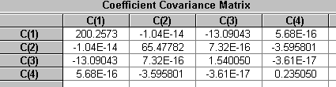

Dependent Variable: Y31
Method: Least Squares
Date: 03/18/06 Time: 16:10
Sample: 1 101
Included observations: 101
Y31=C(1)+C(2)*X+C(3)*X^2+C(4)*X^3
 | Coefficient | Std. Error | t-Statistic | Prob.
C(1) | 168.1450 | 14.80610 | 11.35647 | 0.0000
C(2) | 33.17773 | 8.466297 | 3.918800 | 0.0002
C(3) | -45.99087 | 1.298416 | -35.42076 | 0.0000
C(4) | 0.146135 | 0.507256 | 0.288090 | 0.7739
R-squared | 0.933613 | Mean dependent var |  | -222.7774
Adjusted R-squared | 0.931560 | S.D. dependent var |  | 379.1582
S.E. of regression | 99.19152 | Akaike info criterion |  | 12.07078
Sum squared resid | 954378.9 | Schwarz criterion |  | 12.17435
Log likelihood | -605.5744 | F-statistic |  | 454.7133
Durbin-Watson stat | 2.440550 | Prob(F-statistic) |  | 0.000000

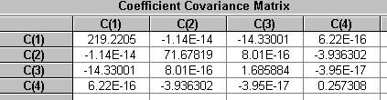

Dependent Variable: Y32
Method: Least Squares
Date: 03/18/06 Time: 16:10
Sample: 1 101
Included observations: 101
Y32=C(1)+C(2)*X+C(3)*X^2+C(4)*X^3
 | Coefficient | Std. Error | t-Statistic | Prob.
C(1) | 160.9568 | 14.34106 | 11.22350 | 0.0000
C(2) | 16.32756 | 8.200382 | 1.991073 | 0.0493
C(3) | -46.33790 | 1.257634 | -36.84529 | 0.0000
C(4) | 1.030830 | 0.491323 | 2.098068 | 0.0385
R-squared | 0.937612 | Mean dependent var |  | -232.9153
Adjusted R-squared | 0.935683 | S.D. dependent var |  | 378.8363
S.E. of regression | 96.07605 | Akaike info criterion |  | 12.00696
Sum squared resid | 895368.9 | Schwarz criterion |  | 12.11052
Log likelihood | -602.3512 | F-statistic |  | 485.9315
Durbin-Watson stat | 1.995430 | Prob(F-statistic) |  | 0.000000

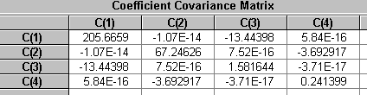

Dependent Variable: Y33
Method: Least Squares
Date: 03/18/06 Time: 16:10
Sample: 1 101
Included observations: 101
Y33=C(1)+C(2)*X+C(3)*X^2+C(4)*X^3
 | Coefficient | Std. Error | t-Statistic | Prob.
C(1) | 136.6808 | 14.63619 | 9.338552 | 0.0000
C(2) | 30.46011 | 8.369139 | 3.639575 | 0.0004
C(3) | -44.55770 | 1.283516 | -34.71536 | 0.0000
C(4) | 0.165665 | 0.501434 | 0.330381 | 0.7418
R-squared | 0.930688 | Mean dependent var |  | -242.0597
Adjusted R-squared | 0.928545 | S.D. dependent var |  | 366.8124
S.E. of regression | 98.05322 | Akaike info criterion |  | 12.04770
Sum squared resid | 932600.1 | Schwarz criterion |  | 12.15127
Log likelihood | -604.4087 | F-statistic |  | 434.1575
Durbin-Watson stat | 2.014749 | Prob(F-statistic) |  | 0.000000

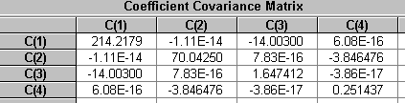

Dependent Variable: Y34
Method: Least Squares
Date: 03/18/06 Time: 16:10
Sample: 1 101
Included observations: 101
Y34=C(1)+C(2)*X+C(3)*X^2+C(4)*X^3
 | Coefficient | Std. Error | t-Statistic | Prob.
C(1) | 147.5474 | 13.99229 | 10.54490 | 0.0000
C(2) | 20.48529 | 8.000954 | 2.560356 | 0.0120
C(3) | -44.91591 | 1.227049 | -36.60481 | 0.0000
C(4) | 0.254645 | 0.479375 | 0.531202 | 0.5965
R-squared | 0.935129 | Mean dependent var |  | -234.2379
Adjusted R-squared | 0.933122 | S.D. dependent var |  | 362.4788
S.E. of regression | 93.73954 | Akaike info criterion |  | 11.95772
Sum squared resid | 852348.8 | Schwarz criterion |  | 12.06128
Log likelihood | -599.8646 | F-statistic |  | 466.0899
Durbin-Watson stat | 2.200506 | Prob(F-statistic) |  | 0.000000

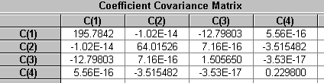

Dependent Variable: Y35
Method: Least Squares
Date: 03/18/06 Time: 16:11
Sample: 1 101
Included observations: 101
Y35=C(1)+C(2)*X+C(3)*X^2+C(4)*X^3
 | Coefficient | Std. Error | t-Statistic | Prob.
C(1) | 131.2075 | 14.27268 | 9.192915 | 0.0000
C(2) | 38.58161 | 8.161281 | 4.727396 | 0.0000
C(3) | -44.79342 | 1.251638 | -35.78785 | 0.0000
C(4) | -0.564929 | 0.488981 | -1.155320 | 0.2508
R-squared | 0.933710 | Mean dependent var |  | -249.5366
Adjusted R-squared | 0.931660 | S.D. dependent var |  | 365.7649
S.E. of regression | 95.61794 | Akaike info criterion |  | 11.99740
Sum squared resid | 886850.8 | Schwarz criterion |  | 12.10097
Log likelihood | -601.8685 | F-statistic |  | 455.4242
Durbin-Watson stat | 2.256735 | Prob(F-statistic) |  | 0.000000

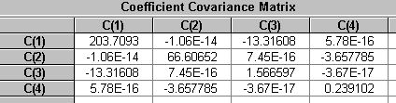

Dependent Variable: Y36
Method: Least Squares
Date: 03/18/06 Time: 16:11
Sample: 1 101
Included observations: 101
Y36=C(1)+C(2)*X+C(3)*X^2+C(4)*X^3
 | Coefficient | Std. Error | t-Statistic | Prob.
C(1) | 160.5089 | 14.41483 | 11.13498 | 0.0000
C(2) | 32.09159 | 8.242564 | 3.893399 | 0.0002
C(3) | -46.08451 | 1.264103 | -36.45628 | 0.0000
C(4) | -0.256439 | 0.493851 | -0.519265 | 0.6048
R-squared | 0.935306 | Mean dependent var |  | -231.2095
Adjusted R-squared | 0.933305 | S.D. dependent var |  | 373.9369
S.E. of regression | 96.57025 | Akaike info criterion |  | 12.01722
Sum squared resid | 904603.9 | Schwarz criterion |  | 12.12079
Log likelihood | -602.8695 | F-statistic |  | 467.4579
Durbin-Watson stat | 2.065635 | Prob(F-statistic) |  | 0.000000

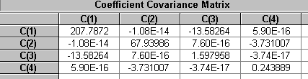

Dependent Variable: Y37
Method: Least Squares
Date: 03/18/06 Time: 16:11
Sample: 1 101
Included observations: 101
Y37=C(1)+C(2)*X+C(3)*X^2+C(4)*X^3
 | Coefficient | Std. Error | t-Statistic | Prob.
C(1) | 155.8273 | 13.67985 | 11.39101 | 0.0000
C(2) | 30.64838 | 7.822296 | 3.918080 | 0.0002
C(3) | -45.94085 | 1.199650 | -38.29521 | 0.0000
C(4) | 0.009786 | 0.468670 | 0.020879 | 0.9834
R-squared | 0.941583 | Mean dependent var |  | -234.6699
Adjusted R-squared | 0.939776 | S.D. dependent var |  | 373.4492
S.E. of regression | 91.64637 | Akaike info criterion |  | 11.91255
Sum squared resid | 814708.6 | Schwarz criterion |  | 12.01612
Log likelihood | -597.5838 | F-statistic |  | 521.1585
Durbin-Watson stat | 1.585952 | Prob(F-statistic) |  | 0.000000

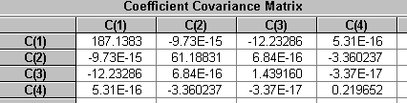

Dependent Variable: Y38
Method: Least Squares
Date: 03/18/06 Time: 16:11
Sample: 1 101
Included observations: 101
Y38=C(1)+C(2)*X+C(3)*X^2+C(4)*X^3
 | Coefficient | Std. Error | t-Statistic | Prob.
C(1) | 157.1882 | 15.68046 | 10.02447 | 0.0000
C(2) | 34.20776 | 8.966266 | 3.815163 | 0.0002
C(3) | -46.84502 | 1.375093 | -34.06681 | 0.0000
C(4) | -0.356162 | 0.537211 | -0.662983 | 0.5089
R-squared | 0.926645 | Mean dependent var |  | -240.9945
Adjusted R-squared | 0.924376 | S.D. dependent var |  | 381.9995
S.E. of regression | 105.0492 | Akaike info criterion |  | 12.18553
Sum squared resid | 1070427. | Schwarz criterion |  | 12.28910
Log likelihood | -611.3694 | F-statistic |  | 408.4438
Durbin-Watson stat | 1.694664 | Prob(F-statistic) |  | 0.000000

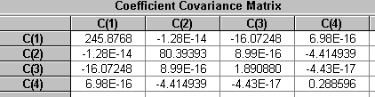

Dependent Variable: Y39
Method: Least Squares
Date: 03/18/06 Time: 16:11
Sample: 1 101
Included observations: 101
Y39=C(1)+C(2)*X+C(3)*X^2+C(4)*X^3
 | Coefficient | Std. Error | t-Statistic | Prob.
C(1) | 147.1113 | 15.61143 | 9.423307 | 0.0000
C(2) | 19.04698 | 8.926797 | 2.133686 | 0.0354
C(3) | -43.92649 | 1.369039 | -32.08563 | 0.0000
C(4) | 0.651196 | 0.534846 | 1.217539 | 0.2264
R-squared | 0.918762 | Mean dependent var |  | -226.2638
Adjusted R-squared | 0.916249 | S.D. dependent var |  | 361.3948
S.E. of regression | 104.5868 | Akaike info criterion |  | 12.17671
Sum squared resid | 1061024. | Schwarz criterion |  | 12.28028
Log likelihood | -610.9238 | F-statistic |  | 365.6722
Durbin-Watson stat | 2.226478 | Prob(F-statistic) |  | 0.000000

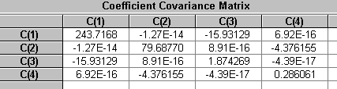

Dependent Variable: Y40
Method: Least Squares
Date: 03/18/06 Time: 16:11
Sample: 1 101
Included observations: 101
Y40=C(1)+C(2)*X+C(3)*X^2+C(4)*X^3
 | Coefficient | Std. Error | t-Statistic | Prob.
C(1) | 150.0083 | 13.79819 | 10.87159 | 0.0000
C(2) | 38.79433 | 7.889962 | 4.916922 | 0.0000
C(3) | -45.91215 | 1.210027 | -37.94306 | 0.0000
C(4) | -0.212755 | 0.472725 | -0.450062 | 0.6537
R-squared | 0.941699 | Mean dependent var |  | -240.2449
Adjusted R-squared | 0.939896 | S.D. dependent var |  | 377.0539
S.E. of regression | 92.43916 | Akaike info criterion |  | 11.92978
Sum squared resid | 828864.8 | Schwarz criterion |  | 12.03335
Log likelihood | -598.4537 | F-statistic |  | 522.2586
Durbin-Watson stat | 2.212355 | Prob(F-statistic) |  | 0.000000

